**ISQS 5347 – Homework Assignment 4**

**Basic Probability Computations and Confidence Intervals**

1. A corporate fleet which operates and manages car rentals for company employees found that the tire lifetime for their vehicles has a mean of 50,000 miles and standard deviation of 3500 miles.
   1. Given a sample of 50 vehicles, do you need to make any assumptions about the underlying distribution of tire lifetime? Explain.

We have taken the assumption that the distribution is normal distribution as the sample size is greater than 30.

* 1. What are the expected values for the mean and standard deviation of the sampling distribution given a sample size of 50?

Standard deviation = Sampling distribution / sqrt (50)

Standard deviation = 3500 / sqrt (50)

Standard deviation ~ 500

Whereas the mean of the Sample size will be the same as that of the normal distribution that is 50,000.

* 1. Determine the 95% confidence interval for a sample of size 50 with a mean of 48,000 miles.



47029.87 <= µ <= 48970.13

1. The Cimberly Klark company would like to start an advertising campaign claiming that one box of tissues will be enough to last the duration of a common cold. Suppose that a box contains 180 tissues. Based on a sample of 40 cold sufferers, Cimberly Klark researchers found that these individuals used on average 175 tissues with a standard deviation of 42.5.
   1. Determine the 95% confidence interval based on this sample.



161.83 <= µ <= 188.18

* 1. Suppose the company wished to have a smaller margin of error in their estimate. Would you recommend they increase or decrease the sample size? Explain.

Sample size needs to be Increase as too smaller the margin of Error in the estimate, as the larger the sample size the smaller will be the uncertainty as the uncertainty decreases the margin of error will be smaller.

1. A quality control engineer is interested in the mean length of sheet insulation being cut automatically by computerized equipment. The desired mean length of the insulation is 12 feet. It is known that the standard deviation of the cutting length is 0.40 feet. A sample of 70 cut sheets yields a mean length of 12.14 feet.
   1. Determine a 90% confidence interval for the mean length cut.



* 1. Determine a 95% confidence interval for the mean length cut.



* 1. Suppose a sample of size 30 also yields a mean length of 12.14 feet. Determine the 90% and 95% confidence intervals based on these values.

90%



95%



* 1. Suppose the population standard deviation is known to be 0.10 feet. Using a sample size of 70 and a sample mean of 12.14, determine the 90% and 95% confidence intervals.

90%



95%



* 1. Based on your computations, what observations can you make about how the width of a confidence interval changes as the desired level of confidence changes? As the sample size changes? As the standard deviation changes?

According to our above computations, we observed that the width of a confidence interval is directly proportional to the level of confidence.

The width of a confidence interval is inversely proportional to the sample size.

The width of a confidence interval is directly proportional to the standard deviation.

1. Suppose that Yellowstone Park is preparing a new advertising brochure claiming that the average duration of Old Faithful eruptions is 3 ½ minutes. Using the R faithful data set, test at the 0.05 level of significance whether the average eruption time is different from 3 ½ minutes.
   1. Test the hypotheses using the critical value method.

Null hypothesis: - eruption time is equal to 3.5 min

Alternate hypothesis: - eruption time is not equal to 3.5 min.



As we can clearly see from the above result that the T Stat is greater than that of the T Value.

Hence we do not reject the null hypothesis.

* 1. Compute the p-value for the sample data. Does it confirm the results of your hypothesis test?



As we know if p-value > α, do not reject H0

Since 0.43>0.05, we do not reject H0.

* 1. Compute the 95% confidence interval for the difference between the means. Does it confirm the results of your hypothesis test?



As the T Stat is greater than that of the T value hence we do not reject the null value.

95% confidence Interval is 3.351534<μ<3.624032

1. The plant manager of a company that manufactures office equipment is considering two different methods of assembly for a new ergonomic office chair. To help decide, 25 randomly selected workers assembled chairs using Method A and another 25 assembled chairs using method B. Assembly times can be found in the starting file on Blackboard. Assume that the distributions of assembly times for the two methods are normally distributed with equal variances. At α = 0.05, is there evidence that there is a difference between the two methods?
   1. Test the hypotheses using the critical value method.

H0: - Chair Created by Method A and Method B has no significant Difference.

Ha: - Chair Created by Method A and Method B has significant Difference.

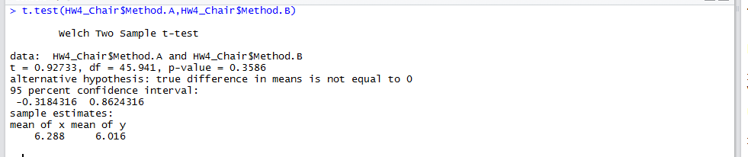

In the above Scenario the p-value is greater than that of the alfa value. Hence null hypothesis is passed.

* 1. Compute the p-value for the sample data. Does it confirm the results of your hypothesis test?



In the above Scenario the p-value is greater than that of the alfa value. Hence null hypothesis is passed.

* 1. Compute the 95% confidence interval for the difference between the means. Does it confirm the results of your hypothesis test?



In the above Scenario the p-value is greater than that of the alfa value. Hence null hypothesis is passed.

95% confidence interval is -0.3184316<μ1-μ2<0.8624316

1. A manufacturing company is interested in whether they can save money by adopting a shorter training period while still achieving desired outcomes for employees. Researchers sampled 15 employees to participate in traditional 3-day training and 12 to participate in revised 2-day training. After the training was complete, the researchers compared exit test scores between the two groups (scores are shown in the data file). At alpha = 0.05 and assuming that population variances are unequal, is there evidence that the two methods achieve different results?
   1. Test the hypotheses using the critical value method.

H0: - 3-day Training and 2-day training has no significant Difference.

Ha: - 3-day Training and 2-day training has significant Difference.

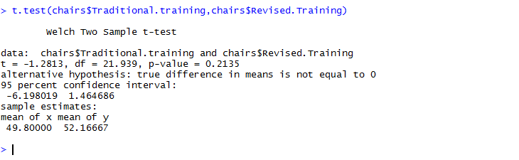

In the above Scenario the p-value is greater than that of the alfa value. Hence null hypothesis is passed.

* 1. Compute the p-value for the sample data. Does it confirm the results of your hypothesis test?



In the above Scenario the p-value is greater than that of the alfa value. Hence null hypothesis is passed.

* 1. Compute the 95% confidence interval for the difference between the means. Does it confirm the results of your hypothesis test?



In the above Scenario the p-value is greater than that of the alfa value. Hence null hypothesis is passed.

-6.198019<μ1-μ2<1.464686

Another approach: -

H0: - 3-day Training and 2-day training has no significant Difference.

Ha: - 3-day Training and 2-day training has significant Difference.

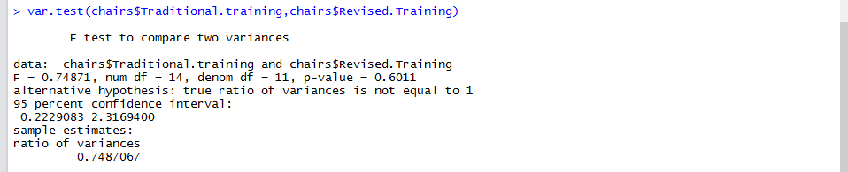

In the above Scenario the p-value is greater than that of the alfa value. Hence null hypothesis is passed.

1. Compute the p-value for the sample data. Does it confirm the results of your hypothesis test?



In the above Scenario the p-value is greater than that of the alfa value. Hence null hypothesis is passed.

1. Compute the 95% confidence interval for the difference between the means. Does it confirm the results of your hypothesis test?



In the above Scenario the p-value is greater than that of the alfa value. Hence null hypothesis is passed.

-6.198019<μ1-μ2<1.464686